|  |
| --- |
| Experiment No. 10 |
| Program to plot graph using matplotlib library. |
| Date of Performance: |
| Date of Submission: |

**Experiment No. 10**

**Title:** Matplotlib in Python

**Aim:** To explore the basics Matplotlib for data visualization.

**Objective:**To understand how to use graphs and charts for data analysis.

**Theory:**Matplotlib is a low level graph plotting library in python that serves as a visualization utility.

Matplotlib is open source and we can use it freely.

Most of the Matplotlib utilities lies under the pyplot submodule, and are usually imported under the plt alias.

* The plot() function is used to draw points (markers) in a diagram.
* By default, the plot() function draws a line from point to point.
* The function takes parameters for specifying points in the diagram.
* Parameter 1 is an array containing the points on the x-axis.
* Parameter 2 is an array containing the points on the y-axis.Eg: (0,0), (6,250), (8,350)

**Code:**

import matplotlib.pyplot as plt

import numpy as np

# Sample data

x = np.linspace(0, 10, 100)

y1 = np.sin(x)

y2 = np.cos(x)

y3 = x ** 2

y4 = np.exp(x)

# Create a figure and subplots

fig, axs = plt.subplots(3, 2, figsize=(12, 10))

# Line Plot with Dots

axs[0, 0].plot(x, y1, label='sin(x)', color='blue', marker='o')

axs[0, 0].plot(x, y2, label='cos(x)', color='aqua', linestyle='--', marker='s')

axs[0, 0].set_title('Line Plot with Dots')

axs[0, 0].legend()

# Scatter Plot with Horizontal Lines

axs[0, 1].scatter(y3, x, color='green', marker='^')

axs[0, 1].set_title('Scatter Plot with Horizontal Lines')

# Vertical Bar Plot

categories = ['A', 'B', 'C', 'D', 'E']

values = [10, 20, 15, 25, 30]

axs[1, 0].bar(categories, values, color='orange', alpha=0.7)

axs[1, 0].set_title('Vertical Bar Plot')

# Horizontal Bar Plot

axs[1, 1].barh(categories, values, color='coral', alpha=0.7)

axs[1, 1].set_title('Horizontal Bar Plot')

# Pie Chart with Marker

sizes = [20, 30, 25, 15, 10]

labels = ['A', 'B', 'C', 'D', 'E']

axs[2, 0].pie(sizes, labels=labels, autopct='%1.1f%%', startangle=140, colors=['gold', 'yellowgreen', 'lightcoral', 'lightskyblue', 'lightgreen'], explode=(0, 0, 0.1, 0, 0))

axs[2, 0].set_title('Pie Chart with Marker')

# Dotted Graph with Vertical Lines

axs[2, 1].plot(x, y4, color='magenta', linestyle=':', marker='x')

axs[2, 1].set_title('Dotted Graph with Vertical Lines')

# Adjust layout

plt.tight_layout()

# Show the plot

plt.show()

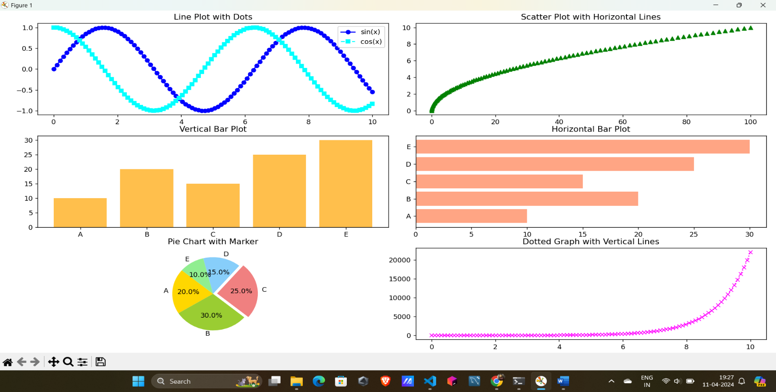**Output:**

**Conclusion**: Thus we have studied different types of plotting using MatplotLib